The Coming King
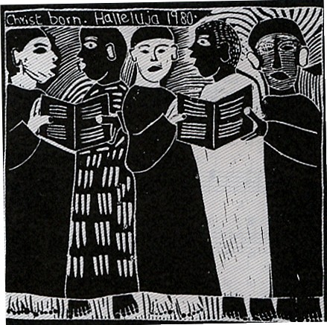

The people who walked in darkness
have seen a great light;
those who lived in a land of deep darkness –
on them light has shined.
You have multiplied the nation,
you have increased its joy;
they rejoice before you
as with joy at the harvest,
as people exult when dividing plunder.
For the yoke of their burden,
and the bar across their shoulders,
the rod of their oppressor,
you have broken as on the day of Midian.
For all the boots of the tramping warriors
and all the garments rolled in blood
shall be burned as fuel for the fire.
For a child has been born for us,
a son given to us;
authority rests upon his shoulders;
and he is named
Wonderful Counselor, Mighty God,
Everlasting Father, Prince of Peace.
Isaiah 9: 2-6

